Aim : Write a program in c to perform traversal of an array

Input: 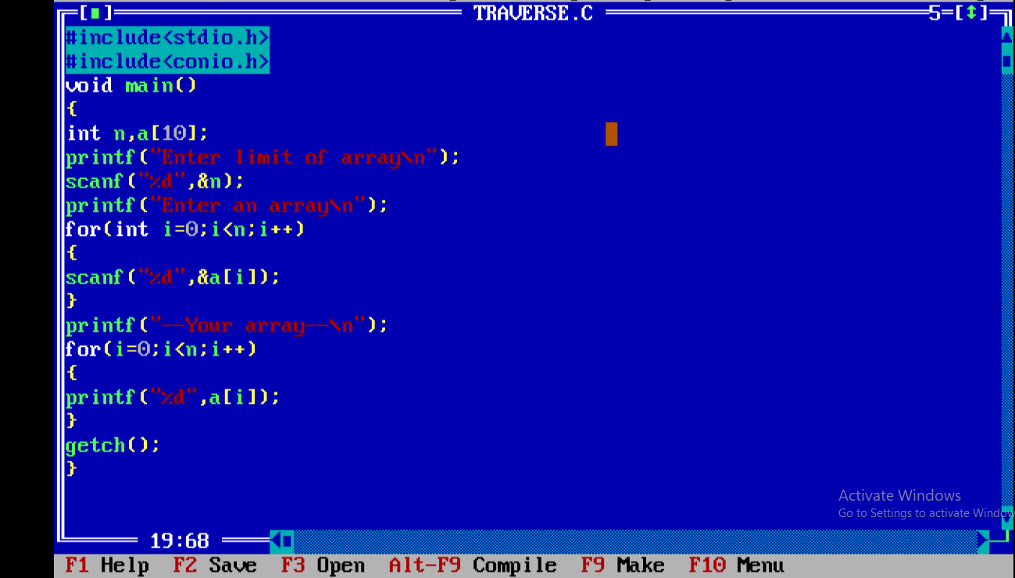

Output :

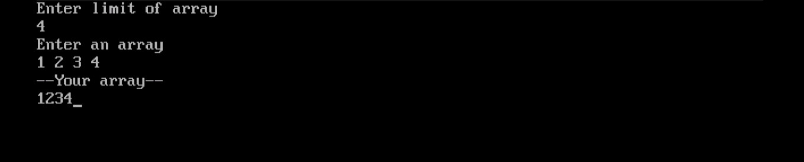

Aim : Write a program in c to perform to perform binary search

Input :

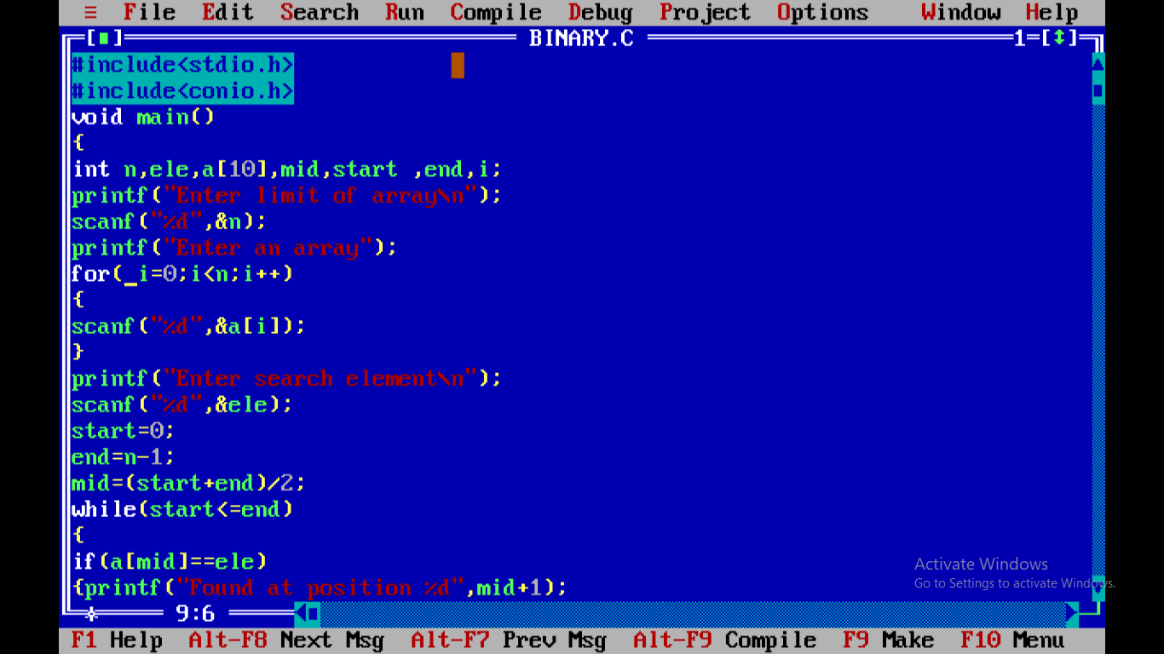

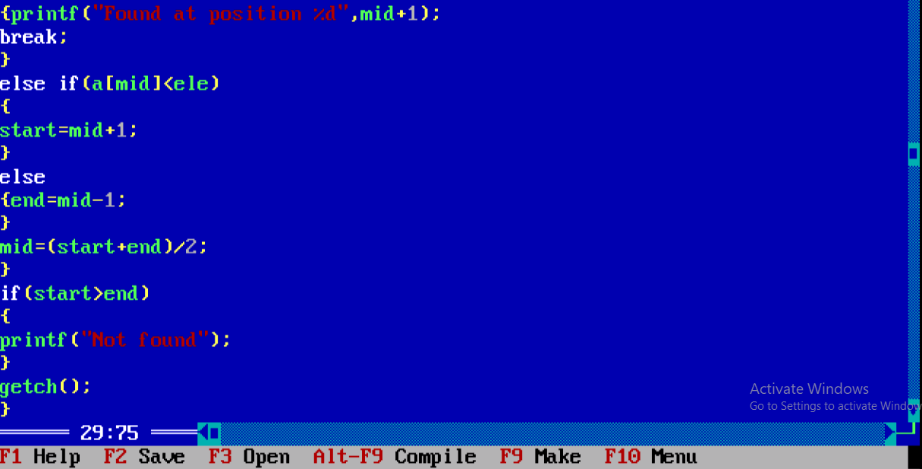

Output : 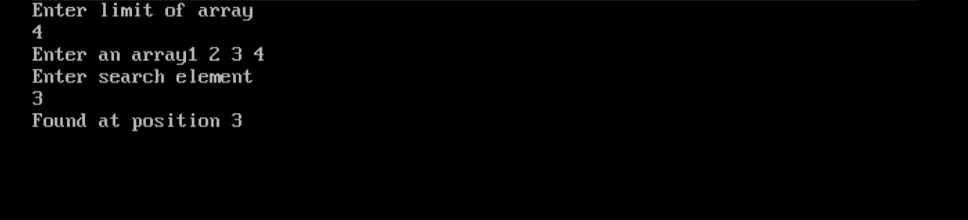

Aim : Write a program in c to perform linear search of an array

Input : 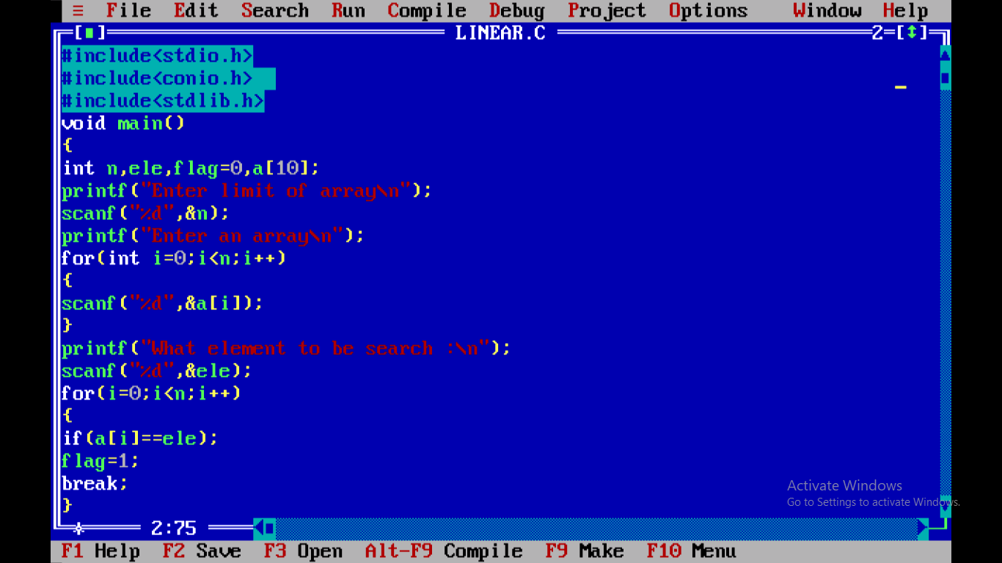

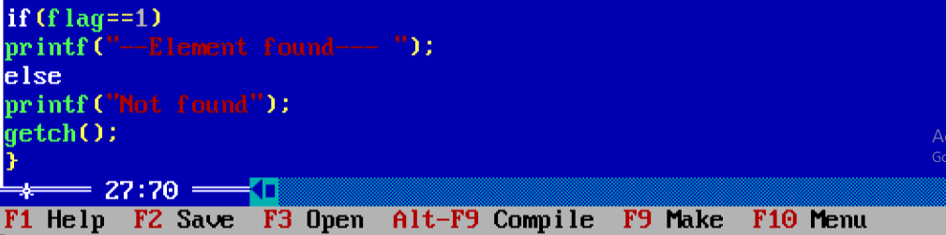

Output : 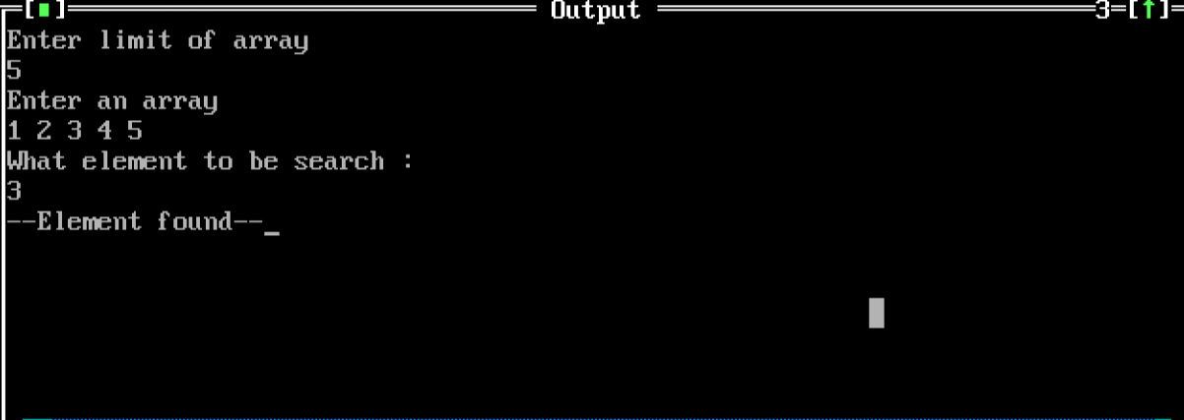

Aim: Write a program in c to perform insertion sort in array

Input :

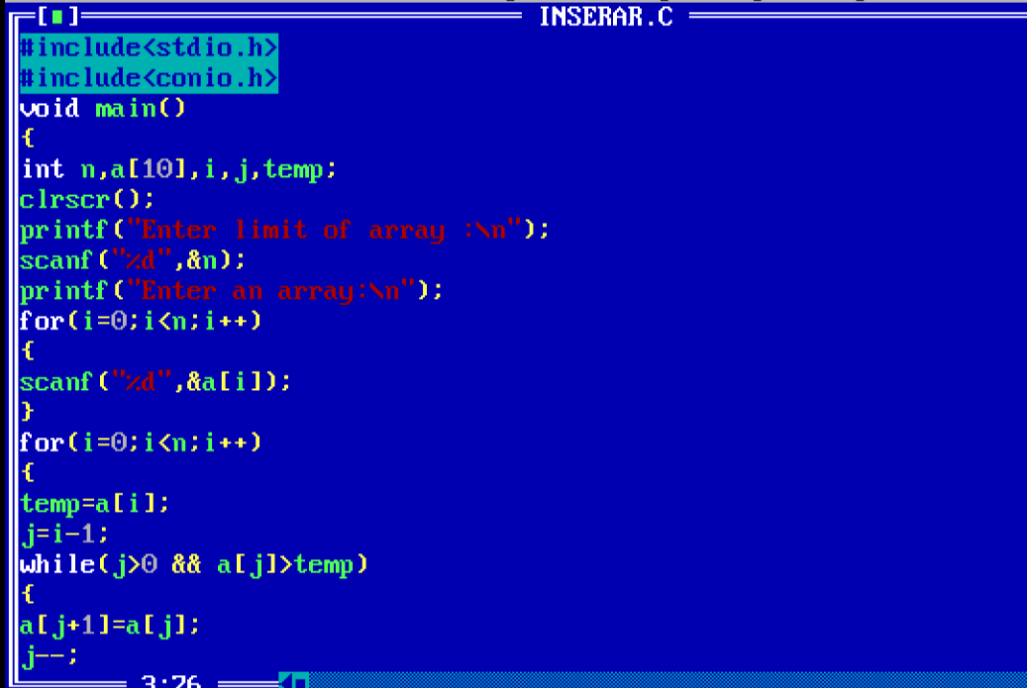

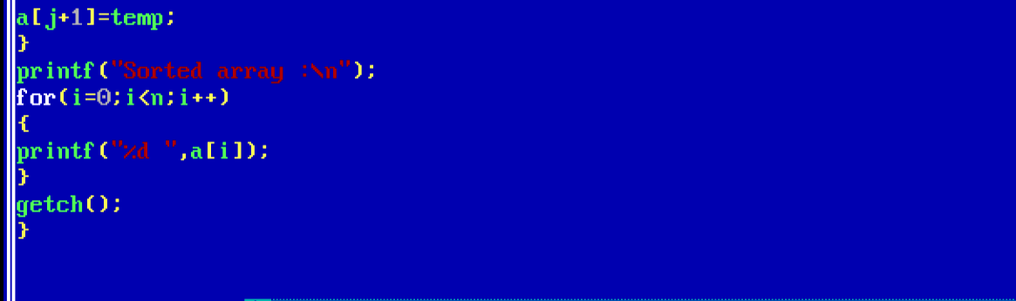

Output :

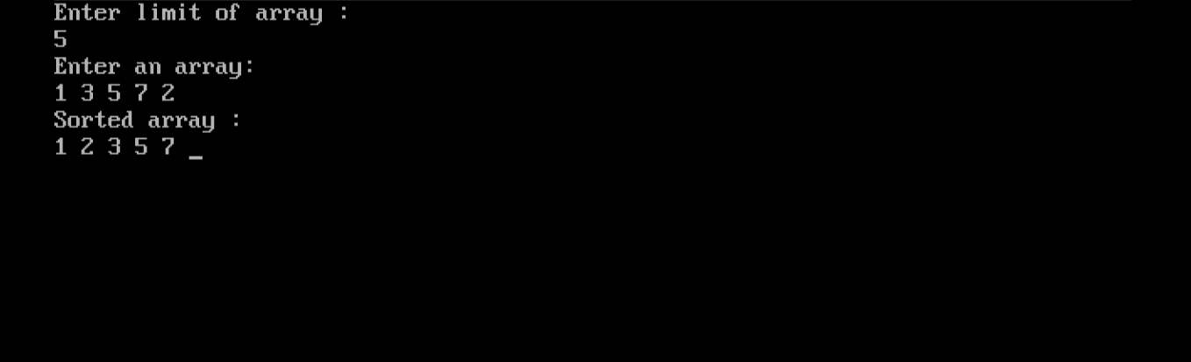

Aim : Write a program in c to perform selection sort

Input : 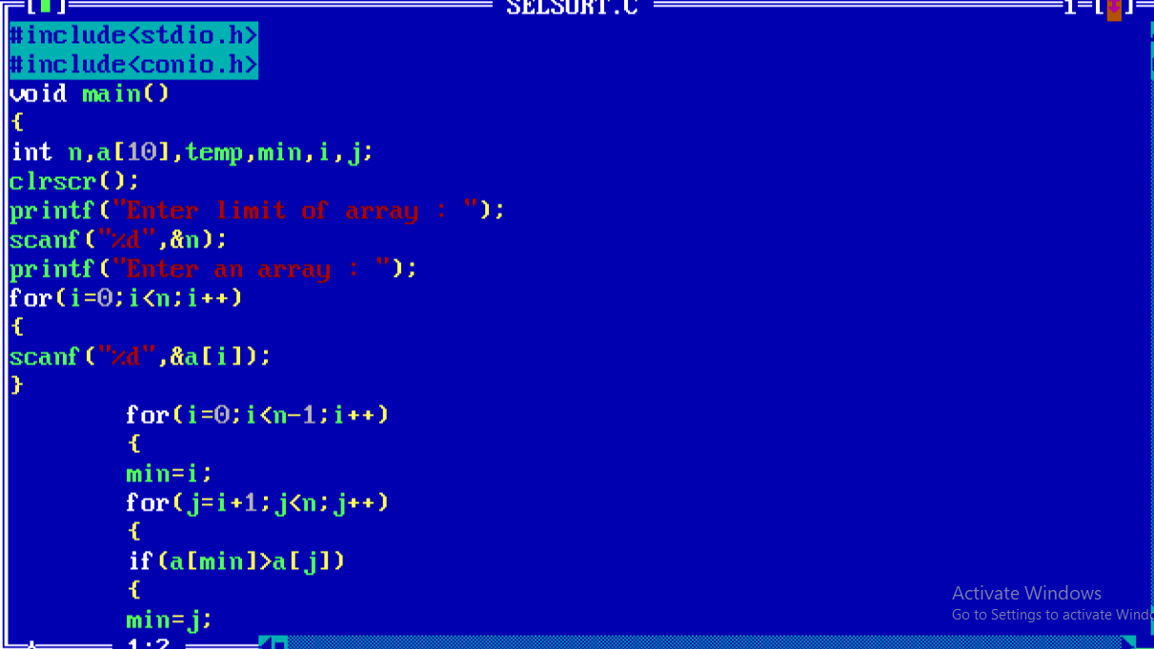

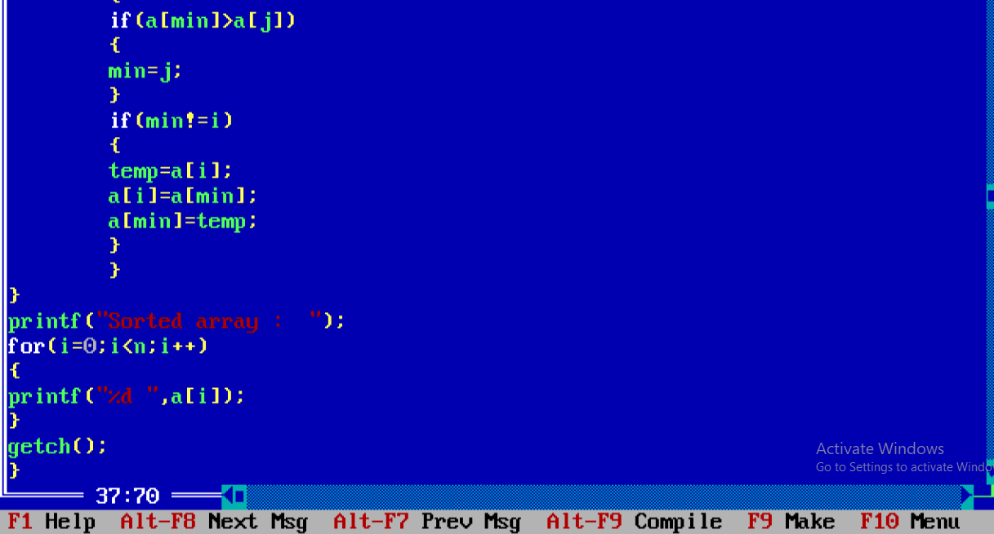

Output :

